The Kerala Academy Module Helps to maintain the person enrolled courses in the academy.

You can find the module in the apps. Once you got the module in your custom path.

You can activate the module to install.

Once You installed the module. You can find the Academy Menu in the main menu.

Click that, it will take you to the Kerala Academy view.

Under the Kerala Academy You can find courses. That will be the masters of the courses you can add up to you want.

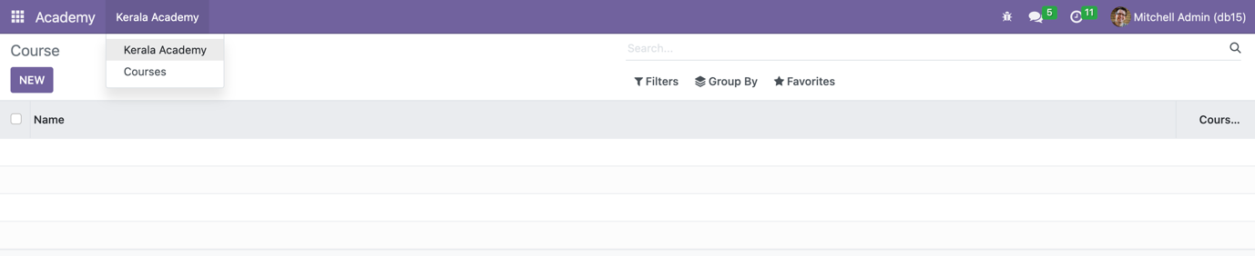

It allow to maintain courses, separately.

In the form view you can find the many2one fields student name and courses.

Total fee is from course master, which not allowed to change (read only). Depends on that Fees paid, the remaining fees has been calculated.

If the fee is not paid fully , the message will appear.